**Shri Vaishnav Vidyapeeth Vishwavidyalaya, Indore**

**Shri Vaishnav Institute of Information Technology**

**Department of computer science and engineering**



**PROJECT**

**B. Tech + MBA(CSE)**

**Subject:Advanced Java Programming**

**Enrollment no.:1810DMBCSE03283**

**Course Code: BTCS-409**

**2ndYear /4th semester**

**Submitted by Subject Teacher**

**Ayush Shrivastava Mr. Sachin Chirgaiya**

**Objective/ Vision:**

To provide ease to the user for confirming transport delivieries or booking.

**Users of the System:**

* Customers

**Functional Requirements:**

* Candidate can register before booking.
* Candidates can login
* Candidates can add their details

**Tools to be used:**

* Use any IDE to develop the project. It may be Eclipse /MyEclipse / NetBeans etc.
* MySQL for the database.
* Apache Tomcate for the server

**Front End and Back End:**

* Front End: JSP,Javascript,AJAX,JDBC
* Back End: MYSQL

**How project works?**

To get detail explanation about project, it includes snapshots with explanation.

Screenshots of output:

Home Page of Transport company->

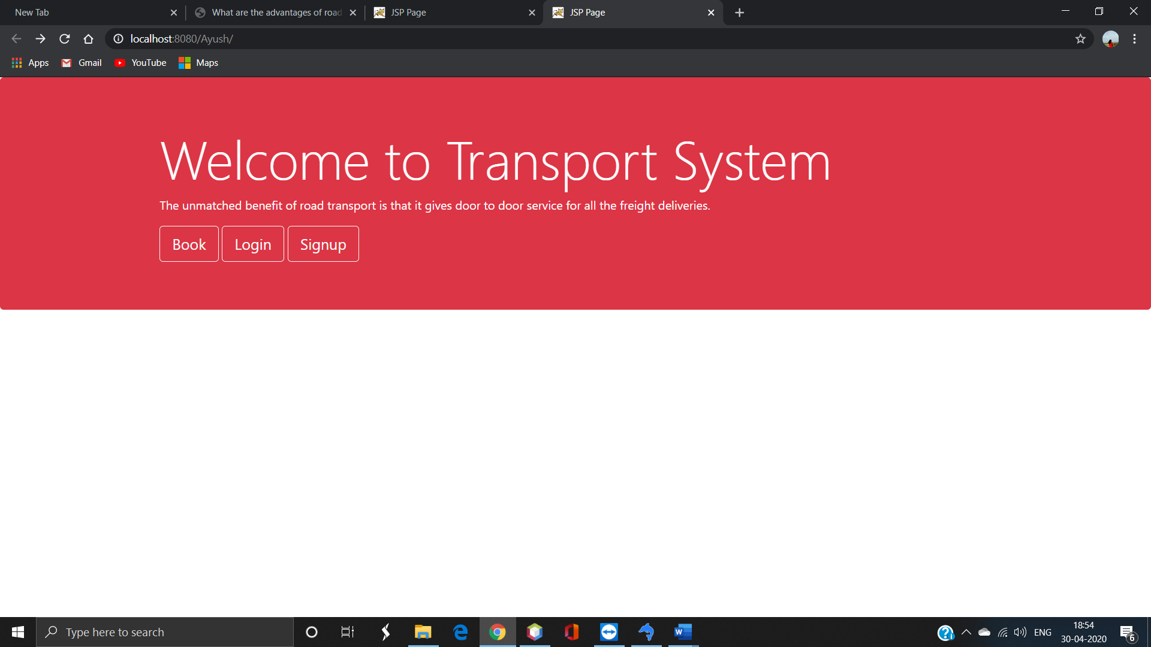

Registering for company->

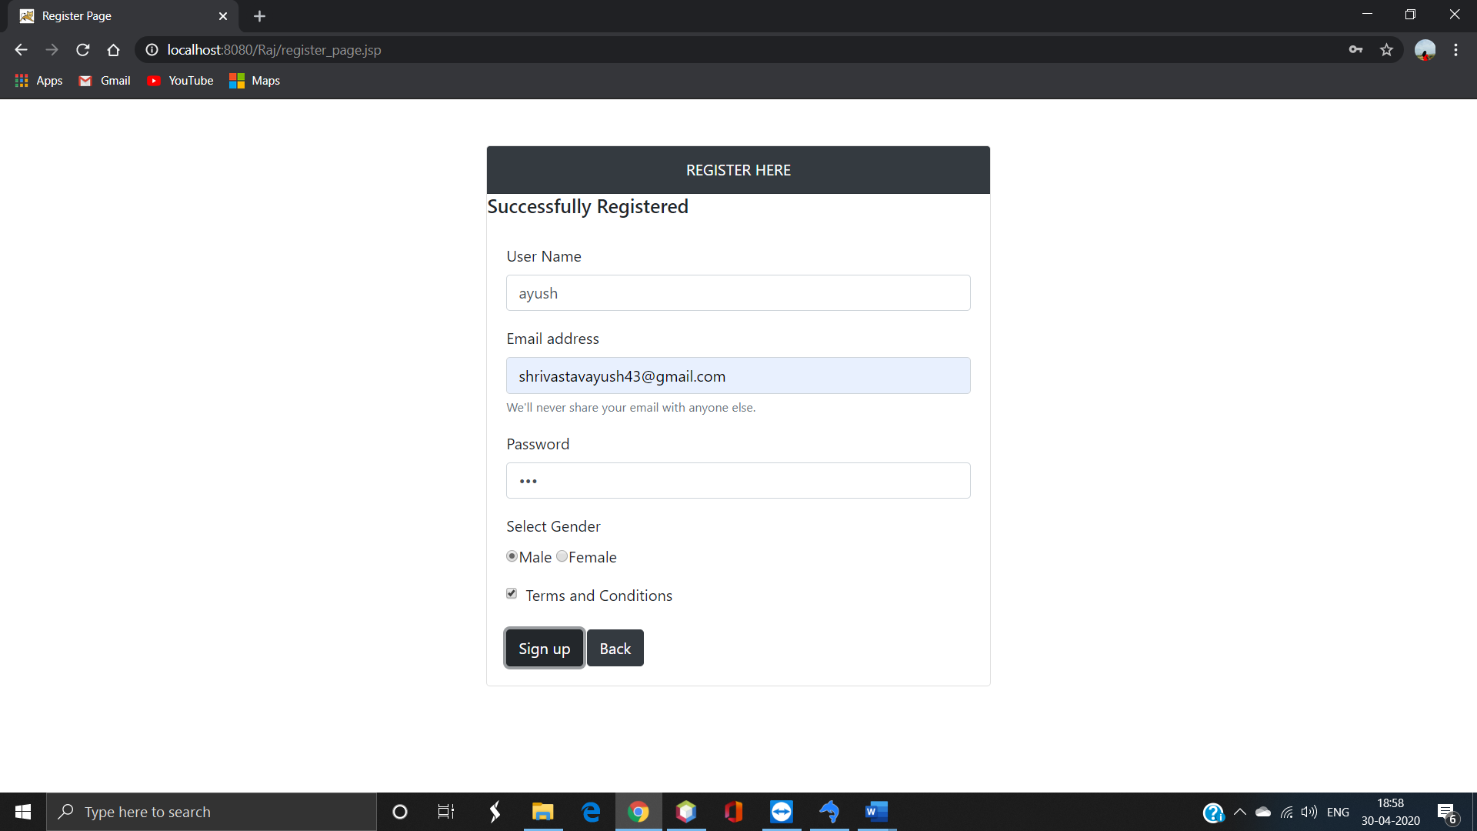

Verification for registration->

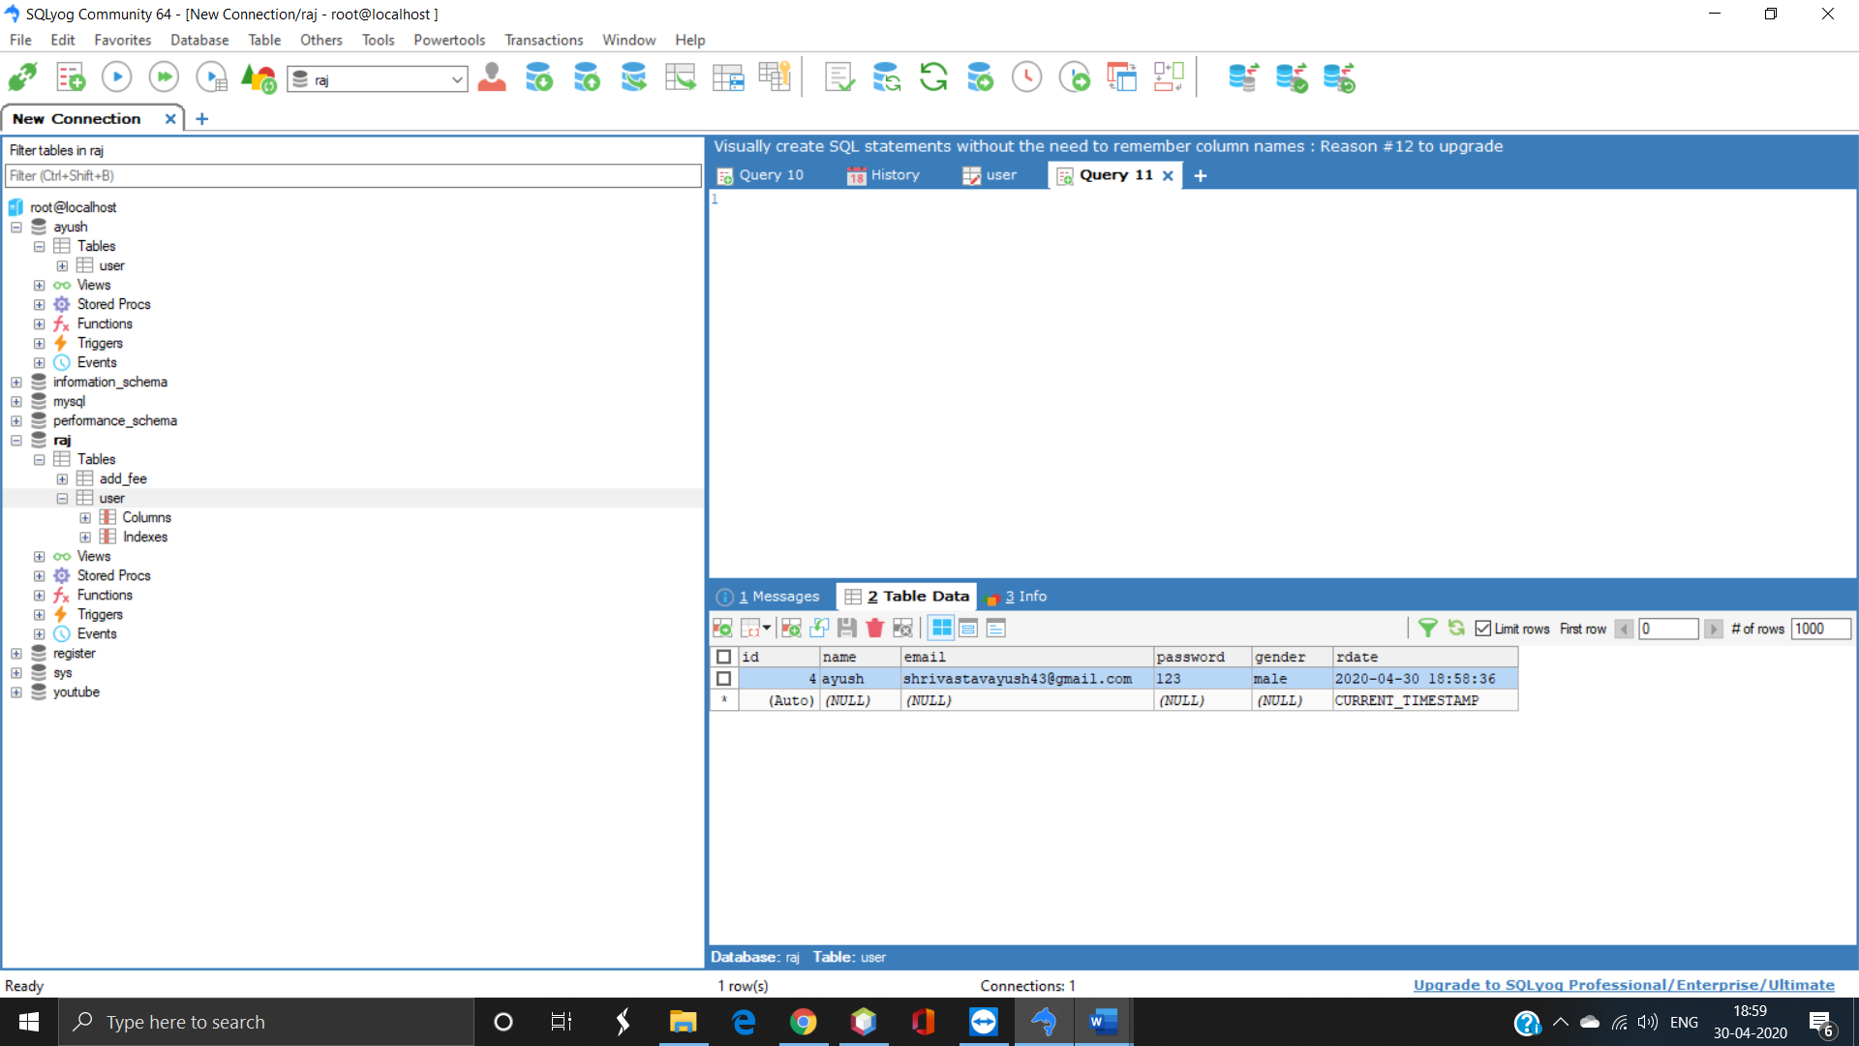

Login to order->

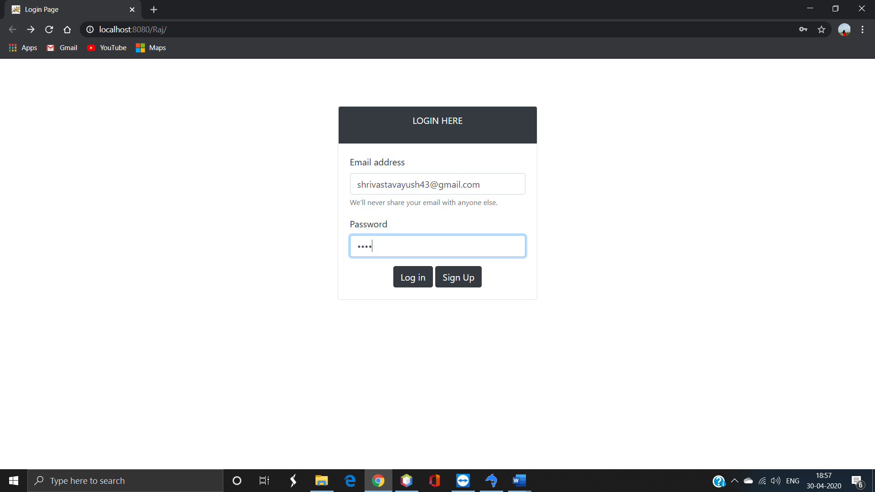

Adding Details->

